SET-C

1.import numpy as np
import matplotlib.pyplot as plt
plt.title("Marks Of Students")
plt.xlabel("Maths")
plt.ylabel("Engilsh")
x = [38,62,18,75,38,59,66,92,52,75,48]
y = [74,44,85,19,88,69,50,33,29,32,56]
plt.scatter(x,y, color = 'red')
plt.show()

OUTPUT

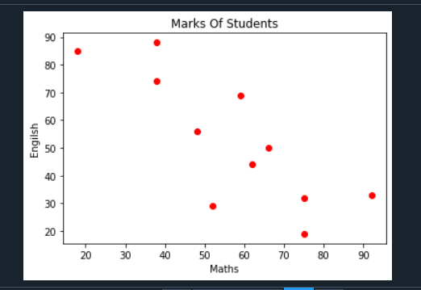

2.def absent_digits(n):
all_nums = set([0,1,2,3,4,5,6,7,8,9])
n = set([int(i) for i in n])
n = n.symmetric_difference(all_nums)
n = sorted(n)
return n
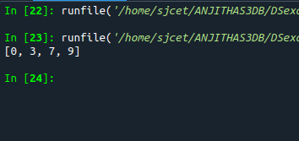
print(absent_digits([5,2,6,1,4,6,8,4]))

OUTPUT

